Conducting Electricity
Have you ever been told that it isn't safe to go swimming if there is the possibility of lightning? Metals like copper make good conductors, but liquids can be good conductors, too. Water can conduct electricity and so can lemon juice!
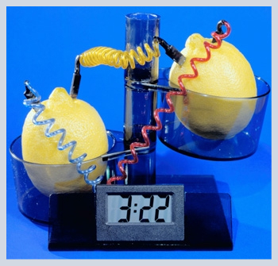
Conductors vs. Insulators
Why is copper used to make wires? Why aren't wires made from plastic? Some materials do a better job of letting electricity flow than others. Conductors allow electricity to go through them easily; whereas, insulators stop electricity from flowing through them.

Making a Lemon Battery
Did you know that you can get electric power from a liquid? Many liquids are good conductors of electricity. How much electrical energy can be squeezed out of a lemon?

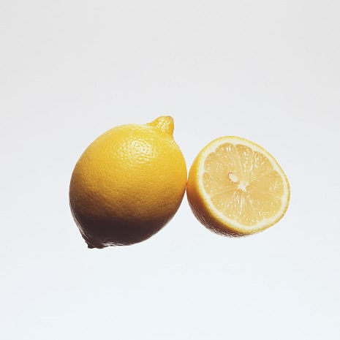

Example Problem: Building a Battery from a Lemon

Directions: View each step below in the example problem.

Materials
Tyler collected the materials he needed for this investigation:
small light bulb (from a flashlight)
2 insulated electrical wires (about 15 cm long, each with about 2 cm of insulation stripped from each end)
1 lemon (preferably large, ripe, and juicy)
2 long, thin objects that are made of different metals or graphite (such as a steel paper clip, a copper nail, or a steel nail)
plastic rod (Tyler used a plastic stick pen for his plastic rod)
drinking glass
kitchen knife
electrical tape
wire strippers

Image 1- Table of materials including a knife, pen, lemon, electrical tape, drinking glass, screw, piece of copper, light bulb, two copper wires and wire cutters

Comments
Tyler had some difficulty observing any change in light from the small light bulb. He found he could see the small glow that resulted if he took his experiment into a dark room. He was able to use the kitchen pantry for this purpose.

Tyler also used a third wire. This enabled him to connect one wire to each electrode so that he didn’t have to keep changing wires each time he used the plastic electrode.

Setup #1
Tyler followed the procedure steps to assemble this apparatus using two different metal electrodes.

Image of screw and copper piece placed in a lemon with a copper wire attached to the screw and another copper wire attached to the copper piece at one end and a small light bulb on the other

Results #1
This is what it looked like when Tyler used the metal electrodes in the apparatus.

Image of screw and copper piece placed in a lemon with a copper wire attached to the screw and another copper wire attached to the copper piece with the other end of both copper wires attached to a small light bulb which is now turned on

Setup #2
Tyler followed the procedure steps to assemble this apparatus using one plastic and one metal electrode.

Image of pen and copper piece placed in a lemon with a copper wire attached to the pen and another copper wire attached to the copper piece at one end and a small light bulb on the other

Results #2
This is what it looked like when Tyler used one plastic electrode in the apparatus.

Image of pen and copper piece placed in a lemon with a copper wire attached to the pen and another copper wire attached to the copper piece with the other end of both copper wires attached to a small light bulb

Setup #3
Tyler squeezed the lemon to create lemon juice. He used the metal electrodes attached to the wire and the light bulb in this setup.

Image of screw and copper piece placed in a glass of lemon juice with a copper wire attached to the copper piece and another copper wire attached to the screw at one end and a small light bulb on the other

Results #3
This is what happened when Tyler lowered the ends of the metal electrodes into the lemon juice.

Image of ends of two copper wires attached to a lit light bulb

Setup #4
Tyler used one plastic electrode attached to the wire and the light bulb along with the glass of lemon juice.

Image of a pen and copper piece placed in a glass of lemon juice with a copper wire attached to the copper piece and another copper wire attached to the pen at one end and a small light bulb on the other

Results #4
This is what happened when Tyler lowered the ends of the plastic electrodes into the lemon juice.

Image of pen and copper piece placed in a glass of lemon juice with a copper wire attached to the copper piece and another copper wire attached to the pen with the other ends of both copper wires attached to a small light bulb

Assignment: Lemon Battery Investigation
Using your observations, answer the questions in this assignment.

